`Dear Contractor(s):

As part of the Personal Identity Verification (PIV) background process, all newly hired contract employees must complete a questionnaire through the Office of Personnel Management’s secure online system, Electronic Questionnaires for Investigations Processing (e-QIP).

We request that you go to the following OPM website: www.opm.gov/e-qip/ to enter the Electronic Questionnaires for Investigations Processing (e-QIP) Gateway and complete a Standard Form 85, Questionnaire for Non-Sensitive Positions. It is recommended that you download the latest version of Adobe Acrobat Reader to avoid any potential printing problems with .pdf forms; please go to their website to download the updated version of the reader <http://www.adobe.com/products/acrobat/readstep2.html>.

Once you have entered the website, please read the "Quick Reference Guide for the Applicant," before you get started. When you are ready to begin, scroll down the page to go to the e-QIP Applicant Site link and follow the prompts to log in.

Once you have completed the online SF-85P form, you will be directed to the Validate, Review, and Certify page. You will end your security investigation application process at this page.
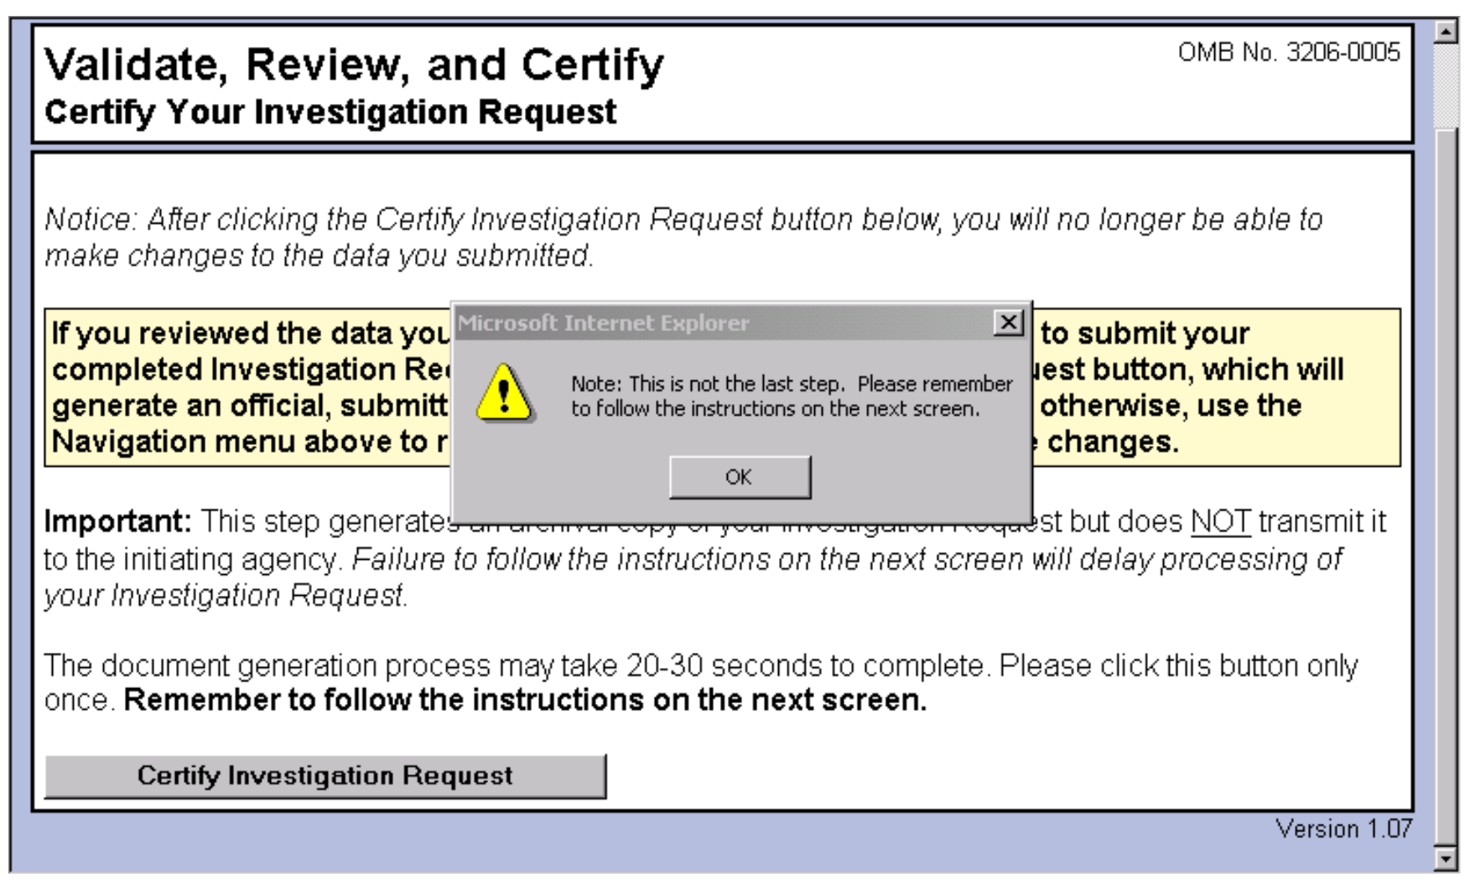

Once you have validated, reviewed and certified your investigation request, please submit the original Signature Forms to Chari Magruder in Room N-4655. Once Signature Pages have been received an ID appointment will then be scheduled.

For MacIntosh Computer Users

e-QIP is not compatible with MacIntosh computers. You may access a fillable version of the form at <http://www.opm.gov/forms/pdf_fill/SF85.pdf>. A continuation sheet, if you need it, can be obtained at <http://www.opm.gov/forms/pdf_fill/SF86A.pdf>. The completed form, to include the Authorization for Release of Information form, must be printed and brought with you on your in-processing appointment.

Please complete the above actions by July 12, 2013.

Please call Chari Magruder at (202) 693-3313 or e-mail e-Clearance@dol.gov if you have any questions regarding this process.

